Visio Lab

How to acquire Visio

Link: <https://e5.onthehub.com/WebStore/Security/SignIn.aspx?ws=1f37dd38-c69b-e011-969d-0030487d8897&vsro=8&rurl=%2FWebStore%2FSupport%2FContactUs.aspx%3Fws%3D1f37dd38-c69b-e011-969d-0030487d8897>

OR Google Microsoft Marist and Imagine

Username is Marist e-mail

Password (if you don’t remember it from Dreamscape, use “Forgot username or password?” link.

Find Visio and follow the directions, it is free, just add it to your cart. Then download the file and install the software. All of the software you see is free as we are members of the Microsoft Alliance.

I used PowerArchiver and it installed from there. You may have to burn it to a DVD.

You have 5 users licenses for each software.

You will need to enter the Product Key

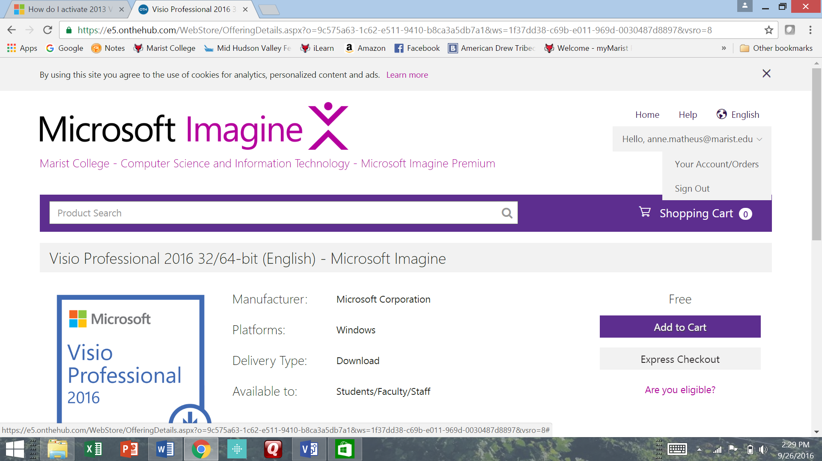

Click on Your Account/Orders

Click on View Details

The product key is under Items.

Using Visio:

Select “Basic Network Diagram”

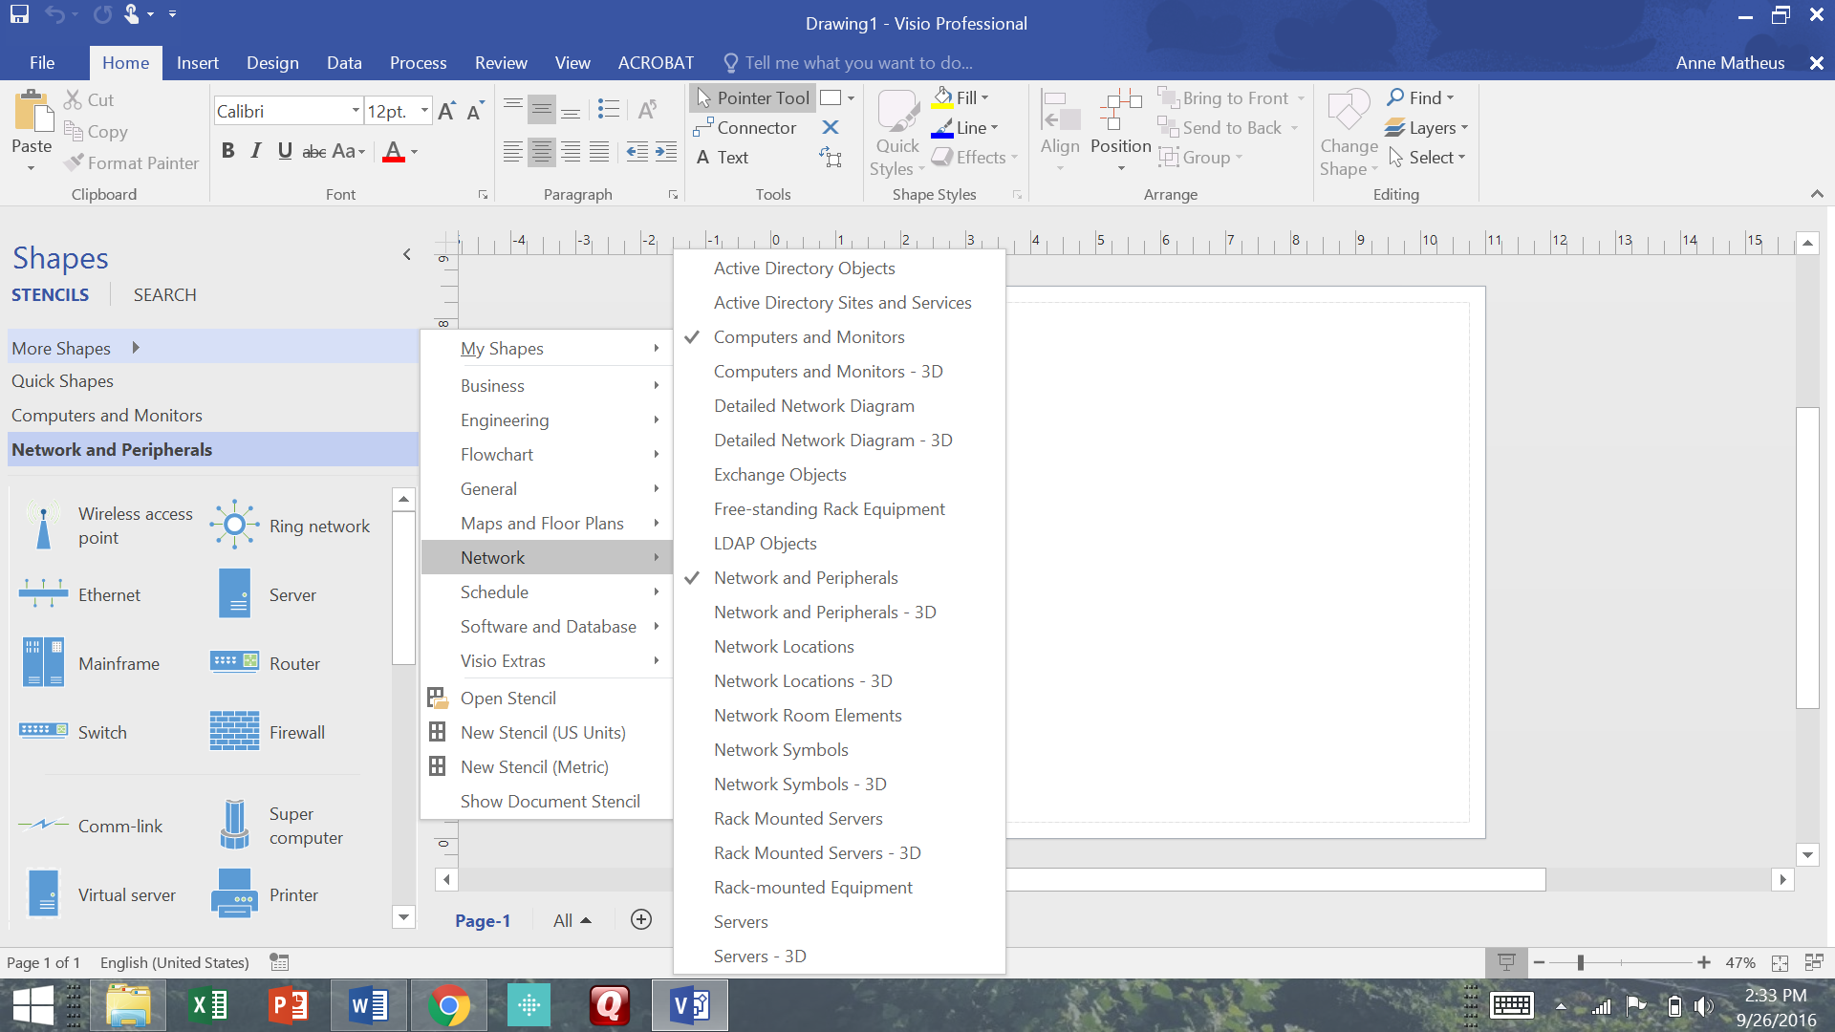There are many network options.

For the lab, re-create the Design assignment from Chapter 1b, use the symbols from Visio and add line speeds and connectivity mediums.